

**COMMISSION ON HIGHER EDUCATION**

Region – IX, Zamboanga Peninsula

Contact No. 991-7648/991-7649

**VEHICLE PASS**

SKELETON WORKFORCE

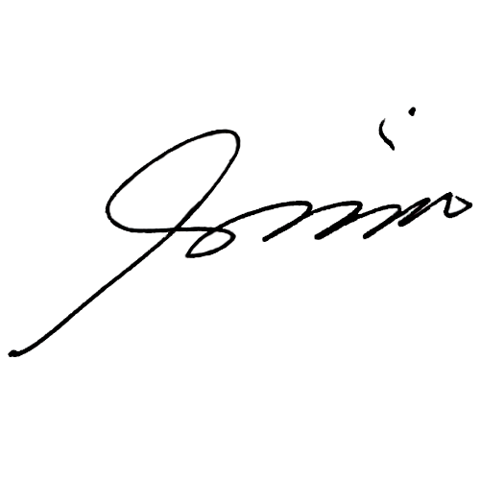

Issued by: **DR. RODY P. GARCIA**

OIC, REGIONAL DIRECTOR

